COMMANDS-02 final report for GPs
Project summary
Liver disease is the only major cause of mortality that is increasing in prevalence in the UK. Non-alcoholic fatty liver disease (NAFLD) is now the most common type, affecting 25% of adults, 70% of people with diabetes and 90% of those who are morbidly obese.
Despite its prevalence, there are few defined management pathways for NAFLD patients. Most patients are diagnosed in primary care, but current community-based management is poorly defined with significant gaps in expertise.
While many patients have ‘simple’ NAFLD, some patients progress to more severe forms, including cirrhosis or liver cancer. Deciding when to refer patients to a liver specialist is a challenge for GPs.
This innovative project from Hull and East Yorkshire Hospitals NHS Trust brought together GPs and liver specialists through an e-consult clinic, as part of an IT-based integrated care pathway for NAFLD (NAFLD e-ICP).
The NAFLD e-ICP helped to standardise and improve care by detailing necessary investigations to determine the cause and severity of liver disease, and promote early and accurate diagnosis.
Patients presenting in primary care with abnormal liver function tests were entered onto the NAFLD e-ICP. GPs made a referral decision: to manage them in primary care or refer them to a specialist. In complex cases, GPs had the option of referring the patient virtually for an e-consultation with a specialist. The specialist reviewed patient data and provided appropriate management and follow-up advice.
Patients benefited from reduced clinic appointments and duplicated investigations, earlier diagnosis and more appropriate referrals.
In an earlier pilot study, we developed a paper based NAFLD Integrated Care Pathway. However, we found integrating the electronic version into SystmOne more challenging than expected. We found an alternative solution in the Electronic Referral System (ERS) that GPs currently use for ‘Choose and Book’ appointments.
We worked closely with Clinical Commissioning Groups and the Hull and East Yorkshire Hospitals NHS Trust IT department to integrate the NAFLD e-ICP into the clinical service directory using the ERS as the mechanism for referral. Almost all of the pertinent primary care blood test results are auto-populated into the referral form. It proved to be a viable tool in its new form and GPs liked it because it was a referral mechanism they were used to using. Unfortunately the interactive NAFLD educational tool for use by GPs could not be integrated into the same package. GPs were able to access it though a separate web link, but identified this as a barrier to use, largely due to time pressures and short 10 minute consultation slots. Uptake of the NAFLD educational tool has not been as high as we would have liked.
We received Health Research Authority (HRA) approval to conduct our research and GP practices were allocated to either the NAFLD e-ICP group (n=4) or to the Standard Care group (n=4). An even split of GP practices were located geographically in Hull and in East Yorkshire. The delay at the beginning of the project impacted significantly on our capacity to recruit and measure project outcomes. As a result we prospectively recruited 52 participants as opposed to our original target of 200 participants. These patients will continue to attend annual follow up visits for a further 4 years.
Results indicate that the NAFLD e-ICP has the potential to improve practice. Fewer of the NAFLD e-ICP patient referrals had missing liver assessment results and the time from first presentation to referral was quicker. Patient experience and quality of life data that indicates that the project was valued by the participants, particularly where severity of liver damage can be quantified by the Enhanced Liver Fibrosis (ELF) test. The results support the validity of the NAFLD e-ICP and the project team intend to scale up the NAFLD e-ICP across Hull and East Yorkshire in 2018/19.
In July 2016, NICE published its NAFLD guidelines, which included in its recommendations the use of ELF biomarker testing in primary care to assess the severity of liver damage. The ELF test is not yet available routinely in the NHS but was already included in our NAFLD e-ICP for research purposes. We used the ELF test results to measure outcomes such as appropriate GP referrals, and informed patients and GPs about disease severity, which guided disease management, monitoring and referral decisions.
Even though we designed the NAFLD e-ICP model to be user-friendly for GPs, time pressure is a frequent barrier to implementing the NAFLD e-ICP to its full potential. GPs involved in this project have been proactive in supporting it and continue to recognise its importance in addressing an increasingly prevalent disease.

Progress and outcomes
The major anticipated outcomes as outlined in our grant application were:

    - Increased GP confidence and expertise in NAFLD management over time, with subsequent reduction in secondary care referrals
    - Demonstrating superiority of the e-consult ICP over current practice will lead to adoption of this approach across the region and beyond
    - A swifter and more clearly defined patient journey with fewer unnecessary investigations and appointments
    - Clearer guidance and explanation of NAFLD and future implications from GPs to patients, strengthening the doctor : patient relationship and empowering patients to take responsibility for self-management of NAFLD
    - Improved access to specialist hepatology advice
We implemented the NAFLD e-ICP project in GP practices. 4 were allocated to the NAFLD e-ICP group and 4 to standard care.
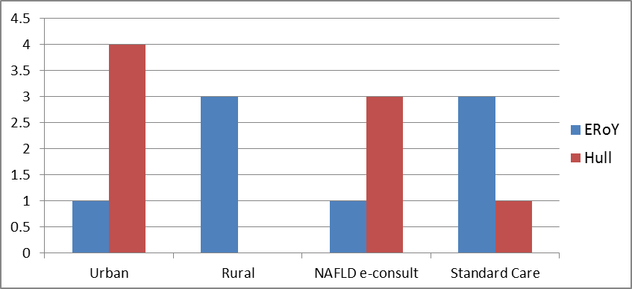
1 GP practice dropped out of the study before recruiting any participants. The practice was replaced by another half way through the project. 8 GP practices have been active in identifying patients and referring them to the research team for consent.
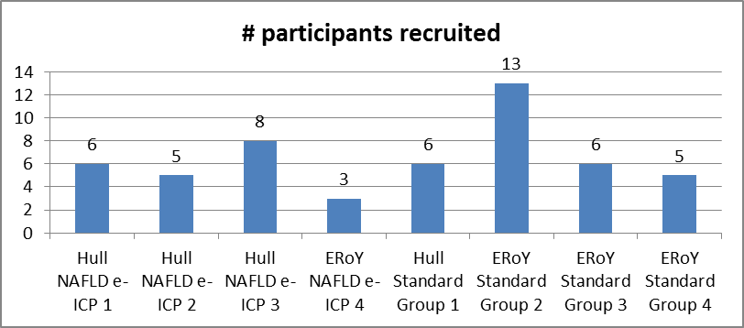
Recruitment was slower than anticipated. GPs state that patients do present with suspected NAFLD but not all have been referred to the research team. Time was the most common reason given by GPs for not identifying patients who may have been eligible for the study. The care pathway referral mechanism, cited as being difficult to follow at the outset of the study, became easier once the system had been used a few times.
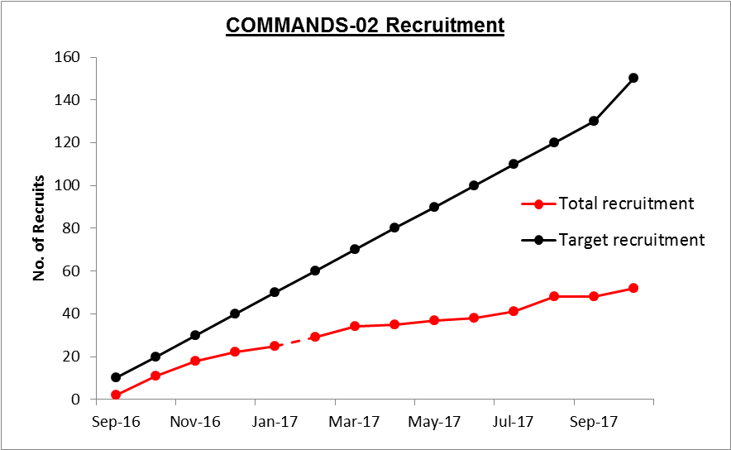
In total, the study recruited 52 patients. Despite the lower than expected number, we able to detect patterns and trends to support the projected outcome: that the NAFLD e-ICP model has the potential to bring about positive change. GP knowledge and practice appeared to improve from baseline in comparison to the standard care group. Patient mapping showed that inappropriate referrals were reduced in the NAFLD e-ICP cohort. In addition, some interesting trends emerged from the patient experience and quality of life data. Patients appear satisified with their quality of life in terms of family, close relationships and careers, but much less so in public, social and recreational acitivities.
The NAFLD e-ICP is shown below as a flow diagram.

NAFLD Advice and Guidance e-consult Referral Service via ERS
Patient presents to GP with abnormal ALT (> 70 IU/mL)

Other cause for abnormal ALT identified
NAFLD suspected by GP

GP uses NAFLD Education Tool to assist assessment and diagnosis

Step 1a Assessment: Lifestyle – alcohol, IV drug use, sexual and travel history, diet, exercise, BMI, Family history of liver disease

Other cause for abnormal ALT identified
Step 1b Assessment : Investigations – FBC, BCP, AST, liver autoantibodies, ferritin, viral hepatitis, lipid profile, Hb1Ac, abdominal US

NAFLD confirmed – referral decision based on liver assessment and NAFLD Score

NAFLD diagnosis confirmed

REFERRAL DECISION

Secondary care paper referral – NOT Choose and Book
NAFLD e-consult clinic referral pathway
Primary care management

Open the auto populating NAFLD View Form and also complete the NAFLD Score calculator

Upload referral form with ERS Advice and Guidance submission to Hepatologist

Hepatologist provides Advice and Guidance reply within 2/52 submission to Hepatologist

Only GPs in the NAFLD e-ICP cohort were given this flow diagram, alongside access to the e-consult referral option and access to the web based NAFLD educational tool.
Standard of Care cohort GPs continued to manage patients without changing practice.
Results for Project outcomes 1, 2 and 3
- Increased GP confidence and expertise in NAFLD management over time, with subsequent reduction in secondary care referrals
- Demonstrating superiority of the e-consult ICP over current practice will lead to adoption of this approach across the region and beyond
- A swifter and more clearly defined patient journey with fewer unnecessary investigations and appointments
We mapped patient data and data collection parameters were clearly defined at the outset with no introduction of bias. The same data collection form was used for all patients.
We used the ‘last 10 patients recruited’ methodology to map patient journeys to eliminate learning errors in using the NAFLD e-ICP. Due to the smaller than anticipated sample size, care should be taken when considering the results.
Patient mapping focuses on investigation, diagnosis and referral along the patient journey
Trend 1: NAFLD e-ICP patients appear to have more timely care than Standard Care.
NAFLD cannot be diagnosed without eliminating other types of liver disease, and none of the patients prior to study entry onto the NAFLD e-ICP or in those Standard Care had a full set of results. Therefore all patients in the study were defined as suspected NAFLD until a complete set of results could confirm the diagnosis. The time between first presentation of raised ALT and the date a patient was documented as having suspected NAFLD.
# days from suspected diagnosis to complete set of blood results | # days from suspected diagnosis to abdominal ultrasound | # days from suspected diagnosis to a confirmed diagnosis | # days from suspected diagnosis to referral decision
NAFLD e-ICP  Mean: 58.3 days  Median: 42 days  Range: -2 to 213 days | NAFLD e-ICP  Mean: 21.9 days  Median: 25 days  Range: -8 to 57 days | NAFLD e-ICP  Mean: 76.5 days  Median: 43.5 days  Range: 13 to 240 days | NAFLD e-ICP  Mean: 88.8 days  Median: 76 days  Range: 0 to 240 days
Standard of Care  Mean: no complete set  Median: n/a  Range: n/a | Standard of Care  Mean: 23 days  Median: 29 days  Range: 1 to 55 | Standard of Care  Mean: no diagnosis  Median: n/a  Range: n/a | Standard of Care  Mean: no referral  Median: n/a  Range: n/a
P value: <0001 | P value: 0.011 | P value: 0.0004 | P value: 0.0007

Trend 2: NAFLD e-ICP patients appear to have more complete liver assessment data, as compared to standard of care patients.
NAFLD e-ICP (Last 10 patients mapping data)
NAFLD e-ICP investigations | Patient 1 | Patient 2 | Patient 3 | Patient 4 | Patient 5 | Patient 6 | Patient 7 | Patient 8 | Patient 9 | Patient 10
Body Mass Index | Done | Done | Done | Done | Done | Done | Done | Done | Done | Not done
Weekly alcohol intake | Done | Done | Done | Done | Done | Done | Done | Done | Done | Not done
Metabolic syndrome risk factors | Done | Done | Done | Done | Done | Done | Not Done | Done | Done | Done
Risky lifestyle behaviour factors | Done | Done | Done | Not done | Not done | Not done | Not Done | Not Done | Not Done | Not Done
Ultrasound | Done | Done | Done | Done | Done | Done | Done | Done | Done | Done
Blood tests for disease aetiology | Done | Done | Done | Done | Not Done | Partial* | Not Done | Done | Done | Not Done
GP diagnosis confirmed | Done | Done | Done | Done | Not Done | Not Done | Not Done | Done | Done | Not Done
NAFLD Fib score | Done | Done | Done | Done | Done | Done | Not Done | Done | Done | Not Done
Referral to e-consult | no | yes | no | no | yes | yes | no | no | no | no
Referral to hepatology OPA | no | yes | no | no | yes | yes | no | no | no | no
Consultant diagnosis | n/a | NAFLD | n/a | n/a | NAFLD | NAFLD | n/a | n/a | n/a | n/a
*where just one test result was outstanding – had been requested but not processed.

Standard of Care (Last 10 patients mapping data)
NAFLD investigations | Patient 1 | Patient 2 | Patient 3 | Patient 4 | Patient 5 | Patient 6 | Patient 7 | Patient 8 | Patient 9 | Patient 10
Body Mass Index | Not Done | Done | Done | Done | Done | Done | Done | Done | Done | Done
Weekly alcohol intake | Not Done | Not Done | Done | Done | Done | Done | Done | Done | Done | Done
Metabolic syndrome risk factors | Done | Not Done | Done | Not done | Done | Not done | Not done | Done | Done | Done
Risky lifestyle behaviour factors | Not Done | Not done | Not done | Not done | Not done | Not done | Not done | Not done | Not done | Not done
Ultrasound | Done | Not done | Not done | Not done | Not done | Done | Done | Not done | Done | Not done
Blood tests for disease aetiology | Not Done | Not Done | Not Done | Not done | Not done | Not done | Not done | Not done | Not done | Not done
GP diagnosis confirmed | Not Done | Not Done | Not Done | Not done | Not done | Not done | Not done | Not done | Not done | Not done
NAFLD Fib Score | Not Done | Not Done | Not Done | Not done | Not done | Not done | Not done | Not done | Not done | Not done
Referral to e-consult | n/a | n/a | n/a | n/a | n/a | n/a | n/a | n/a | n/a | n/a
Referral to hepatology | no | Yes on ELF | no | yes on ELF | yes on ELF | no | no | no | no | no
Consultant diagnosis | n/a | ARLD | n/a | pending | pending | n/a | n/a | n/a | n/a | n/a

60% (n=6) NAFLD e-ICP participants had a complete set of NAFLD investigations (BCP, AST, Ferritin, Liver Autoantibodies, lipids, virology, HBA1c, FBC, USS) compared to 0% (n=0) of standard of care participants.
60% (n=6) NAFLD e-ICP participants had a confirmed diagnosis of NAFLD compared to 0% (n=0) of standard of care participants.
90% (n=9) NAFLD e-ICP participants had a complete metabolic syndrome assessment (diet and exercise documented on GP database) compared to 60% (n=6) of standard of care participants
30% (n=3) of NAFLD e-ICP participants had a risky lifestyle assessment (IVDU, sexual or tattoo history) compared to 0% (n=0) of standard of care participants
90% (n=9) of NAFLD e-ICP participants had alcohol assessments compared to 80% (n=8) of standard of care participants
60% (n=6) NAFLD e-ICP participants had a non-invasive NAFLD Fibrosis Score (NFS) calculated compared to 0% (n=0) of standard of care participants. Calculating the NFS score can support clinical decision making when staging the severity of NAFLD and deciding whether or not to refer a patient to secondary care. However, the NFS requires an AST result as part of the algorithm and this was the most frequently missed test in both NAFLD e-ICP and standard of care cohorts.
30% (n=3) NAFLD e-ICP participants were referred to the NAFLD e-consult clinic by the GP for advice and guidance. Of these, 100% were referred to secondary care for further investigation.
Standard of care participants did not have access the e-consult clinic.
100% (n=10) of NAFLD e-ICP participants had an abdominal ultrasound compared to 40% (n=4) of Standard of Care participants.

Trend 4: The assessments most often missed are those that require more time to discuss like risky behaviours and diet and exercise habits. This is the same on both NAFLD e-ICP and Standard of Care cohorts.
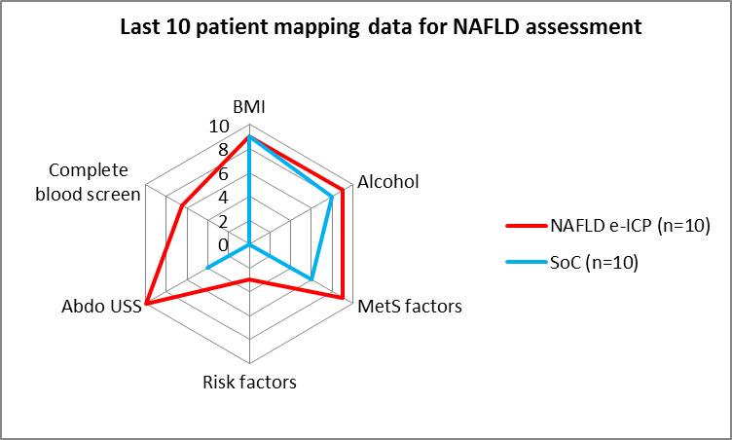
Results for Project outcome 4
Clearer guidance and explanation of NAFLD and future implications from GPs to patients, strengthening the doctor : patient relationship and empowering patients to take responsibility for self-management of NAFLD
The recommendation of ELF biomarker blood testing in primary care in the NAFLD NICE guidelines in July 2016, has brought attention to the importance of assessing disease severity in primary care. Despite the recommendation, ELF testing is not used in primary care due to cost and practical challenges in sending the samples to London for testing. Our project included ELF testing for all participants as an additional test to stage disease severity, guide referral decision and ensure appropriate participants follow up and management.
96% (n=50) participants had an ELF test. Both GPs and patients received the ELF result once a referral decision had been made to avoid bias in patient mapping data.

Trend 5: ELF test results helped to support appropriate decision making:
15% (n=8) participants cross both cohorts had severe fibrosis/cirrhosis on ELF test that required referral to secondary care. 77% (n=40) participants had moderate fibrosis; and 4% (n=2) had mild fibrosis. Both mild and moderate fibrosis can be safely managed in primary care with monitoring and positive healthy lifestyle change.
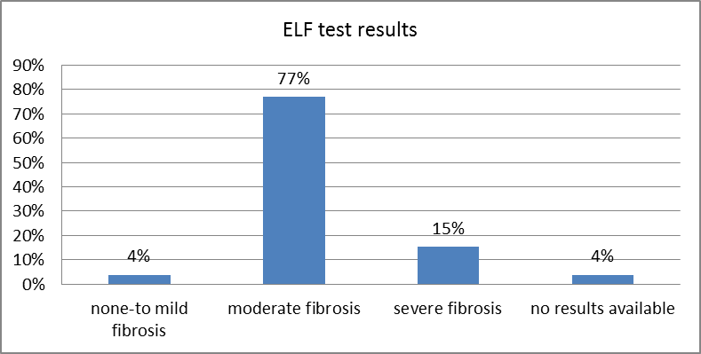
Trend 6: The right patients have been identified by GPs for further investigation in primary care. Only 4% (n=2) participants had a mild fibrosis result. GPs appear to suspect NAFLD in the correct group of patients.
Trend 7: Patients like the NAFLD e-ICP and ELF test option.
Case study 1: One patient expressed his thanks, firstly for giving him an opportunity to participate in research, but secondly, that someone was looking more closely at managing his abnormal liver blood tests. He said that he had known they were abnormal for some years now, but that no one seemed to really know whether he should be concerned about them or not. He could not understand this. He felt that he had had unnecessary blood tests at his GP practice over the years, wasting his time and the GPs time. Once NAFLD and its symptoms were explained to him and why it is so difficult for GPs to sometimes know what to do for the best, he could understand why a better way to manage his NAFLD was needed. He was very happy to consent to the study and be part of finding a better way for his GP to manage NAFLD in primary care.
Case study 2: One patient was very anxious about her abnormal liver tests and had been told she had NAFLD. She had few of the obvious risk factors for NAFLD, was physically active and had a healthy vegetarian diet. Sometimes patients do not have the usual risk factors but can still be at risk of disease progression. Whilst not needing a referral to secondary care (as shown from the ELF test result) her GP will continue to monitor her for signs of disease progression in line with NICE NAFLD guidance 2016.
Trend 8: Quantitative evidence of disease severity can be a big motivator for patients to make healthy lifestyle changes and helps GPs tailor their advice and support accordingly.
A huge benefit in having the NAFLD e-ICP and ELF test is the GPs ability to reassure patients that they are being looked after most appropriately. Disease progression to more severe disease generally occurs slowly and silently, but can be reversed by implementing healthy lifestyle changes. The earlier the healthy lifestyle intervention the better. The ELF test provides a more understandable indicator of what management decisions need to be made. Most patients who consented to the study, had similar stories of being told they have NAFLD, but did not really know how bad it was or how worried they should be about it.
Participants found that when shown their position along the NAFLD spectrum from mild to cirrhosis according to the ELF test result, patients could visualise ‘how bad or good’ their NAFLD was. Knowing their ELF test result may encourage patients to make important decisions about making positive healthy lifestyles changes.

Trend 9: NAFLD patients appear to have negative feelings about their state of health. Only 18% (n=9) felt their health was better than others and 35% (n=18) of patient felt their health was worse than other people.
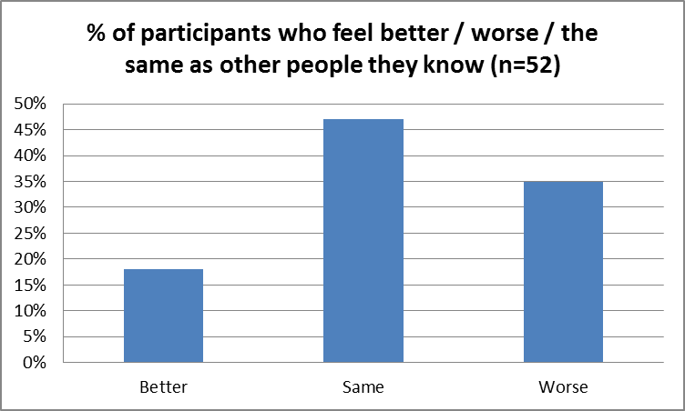
Patient questionnaires reveal that many patients are happy in their close personal relationships but lack confidence outside their network of close family and friends. This may have a negative impact on participation in healthy lifestyle clubs and organisations
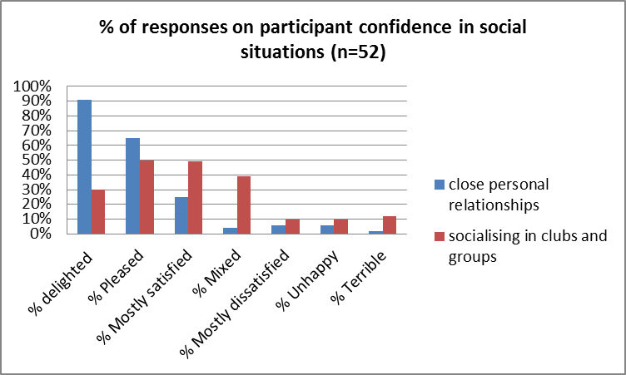
Trend 10: All patients knew that losing weight and taking up exercise are the key ways to reverse NAFLD.
Despite knowing about healthy lifestyles and how effective positive changes can be, many patients had not participated in organised healthy lifestyle changes such as diets or exercise programmes.
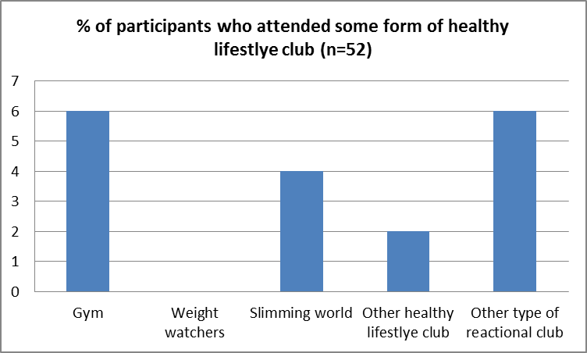
Many patients responded that they are not happy with their social lives or in participating in recreational clubs. It is surprising therefore that more people have not made use of mobile phone apps aimed at promoting healthy lifestyles.
Only 17% (n=9) used a phone ‘app’ to support healthy lifestyle change
Results for Project outcome 4
Improved access to specialist hepatology advice
36% (n=8) of patients in the NAFLD e-ICP arm were referred to the e-consult clinic. 75% (n=6) were subsequently referred to secondary care for further investigation. There were some teething problems at the beginning of the project regarding when to refer a participant to the e-consult clinic. However, after clarifying that the research consent process (research team activity) and the NAFLD assessment pathway (GP assessment activity) could be implemented independently of one another, the referral mechanism appears to have worked well, with no further issues arising.
GPs were expected to follow the NAFLD e-ICP before making an e-consult referral so that they could complete the full set of NAFLD assessments, confirm the diagnosis and make an appropriate referral decision. The results were attached via the NAFLD e-consult referral form via ERS for review by the specialist.
However, 5 e-consult referrals were rejected because of incomplete results with advice on what needed to be completed. This occurred largely in the early stages of the project. The e-consult clinic can only be useful if the liver specialist has full access to the primary care test results. 1 patient was referred before being recruited to the study and could therefore not be accepted. The patient was later consented to the study and assessed in primary care as per the NAFLD e-ICP.

Conclusion:
Significant key trends have emerged from the data:
1) The NAFLD e-ICP appears to improve all aspects of the quality of NAFLD assessment, diagnosis and referral decision making in primary care.
2) The NAFLD e-ICP used the ELF test to confirm referral appropriateness. In 15% (n=8) of cases, the ELF triggered a secondary care referral that would otherwise not have been made. NICE NAFLD guidance now recommends the ELF test as part of routine primary care, but it remains both costly and logistically impractical. It is unlikely to available routinely for a while yet.
3) The NAFLD e-ICP e-consult clinic appears to have been positively received by GPs. More participant data is probably needed before a conclusion can be reached about its true value, both economically and from a quality perspective. Both local CCGs are supportive of the service and it will continue for all GPs across Hull and East Riding of Yorkshire. This will require a scale-up project as the e-consult clinic referral form needs to be uploaded onto GP systems in order to auto-populate NAFLD assessment data.
4) The NAFLD e-ICP appears to have been a positive participant experience with 100% of participants satisfied with their experience. 71% felt they had an increased understanding of NAFLD with ELF test results potentially motivating participants to engage more in positive healthy lifestyle change.
This project shows that it has the potential to improve the quality of care for NAFLD patients in primary care, as well as supporting patients to make healthy lifestyle changes. More evidence is needed, particularly from economic and long term clinical outcome perspectives, to understand the NAFLD e-ICP role as a routine clinic service across the region.
Key Recommendations:
Stage 1 of the NAFLD e-ICP: Non-invasive assessment:
• Metabolic syndrome risk factors: hypertension, T2DM, CKD, PCOS, High LDL / TG
• Document alcohol, BMI, waist circumference, diet, exercise, herbal medications, and risky lifestyle behaviours (e.g. tattoos, travel etc.)
Stage 2 of the NAFLD e-ICP: Invasive assessment
• Request AST as well as BCP (not on the BCP panel of tests, so request separately)
• Request FBC (low platelets may indicate possible cirrhosis).
• Use BCP, AST and Platelets to calculate non-invasive disease severity algorithms e.g. NAFLD Fibrosis Score (NFS), FIB-4 or FLI
• Request virology screen to rule out viral hepatitis
• Request autoantibodies to rule out autoimmune disease (PBC, PSC, AIH)
• Request a ferritin to rule out Haemochromatosis
• Request an abdominal ultrasound if greater than 2 x ULN ALT results in 6 months

Points to mention:
Use the NAFLD Fibrosis score (or FIB-4 or FLI) to support a referral decision, but use your clinical judgement to make the final referral decision.
Abnormal LFTS are not a reliable indicator of disease severity. People with advanced disease may only have borderline LFTs.
NICE NAFLD guidelines 2016 outline NAFLD management recommendations

