Depression and Anxiety Service – Let’s Talk
Engagement Findings Summary

Introduction
The existing depression and anxiety service, Let’s Talk, is run by City Health Care Partnership; the contract term is approaching. The CCG needs to determine if the service should be re-procured or the contract extended with some service improvement. Over the course of the exisiting contract the service has developed to respond to the changing behaviour and needs of service users, with particular focus on reducing the high DNA rates the service experiences.

Goals
The goals of this engagement exercise are:
- To gauge professional experience and views of the service, both working with and for the service.
- To use the experience and views of people accessing the service, to identify the valued aspects of service and areas for improvement.
- To use public views and experiences of mild to moderate mental health issues to give insight into what people may require from services in the future.

Methodology
Three online questionnaires were developed, one for each of the following stakeholders; general practitioners, patients and the public. The public facing questionnaire was promoted on facebook using two promoted posts, one general post and one aimed at men. The public questionnaire asked if people had accessed the Let’s Talk Service, if participants had and agreed to be involved further they were sent the patient questionnaire. The patient questionnaire was also completed in service waiting areas using iPads. The GP questionnaire was promoted using the GP newsletter, council of members and direct email.

Additional work was undertaken with professionals who interact with the service; a table top discussion with GPs was facilitated at the CCG’s council of members meeting on 13th September 2018, and semi-structured interviews were conducted with subcontractors of the existing service.

Engagement Reach
578 people have taken part in this engagement exercise; 489 members of the public, 46 service users and 23 GPs completed their respective questionnaires. 20 GPs took part in the table top discussion and 9 subcontractors were interviewed.

The table below social media interactions on facebook

 | Advert 1 (Male) | Advert 2 | Total
People reached | 11,919 | 11,068 | 22,987
Engagements | 334 | 746 | 1,080
Link clicks | 38 | 294 | 332
Comments | 11 | 16 | 27
Shares | 48 | 88 | 136
Likes, loves, interactions | 88 | 85 | 173
Results
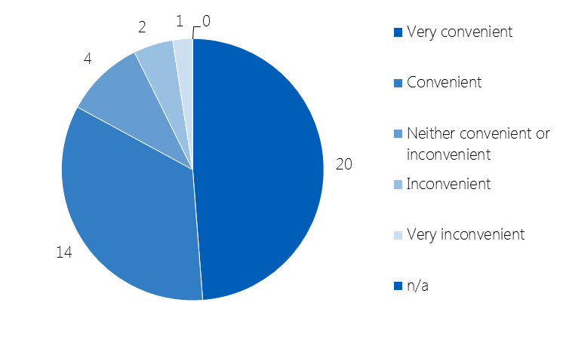
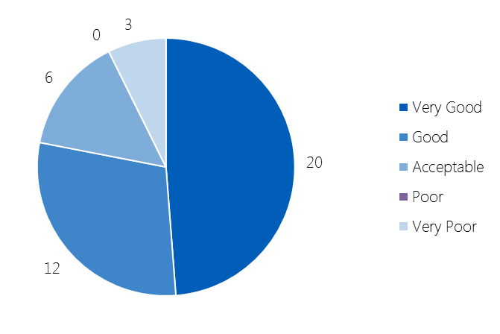
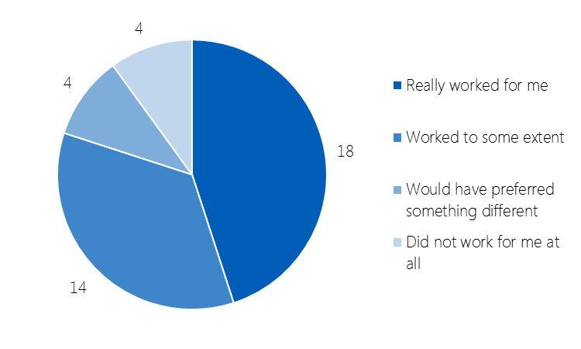
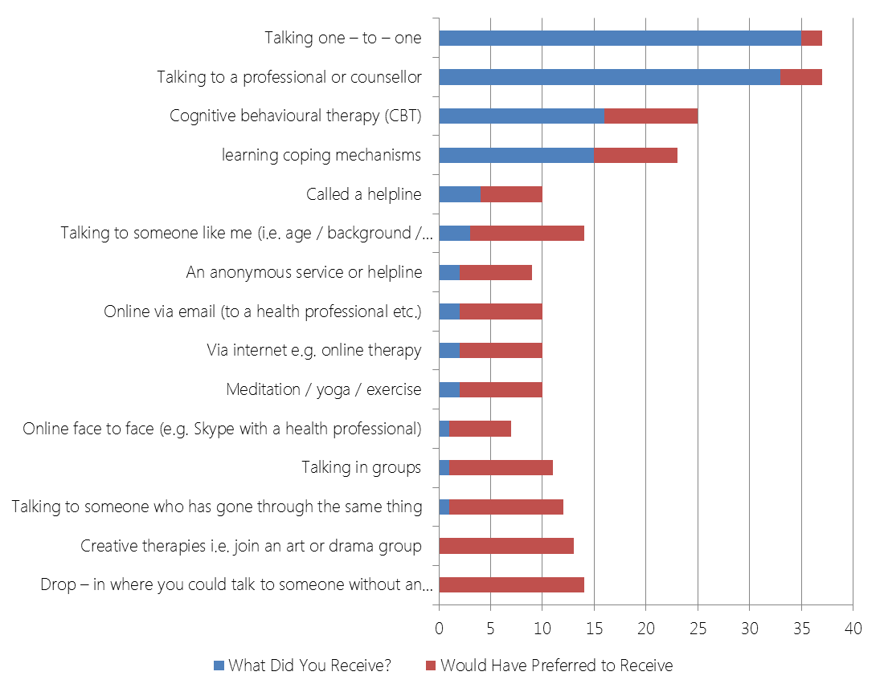
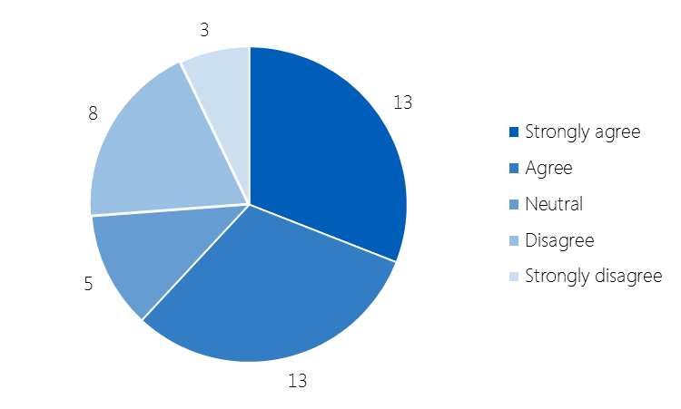
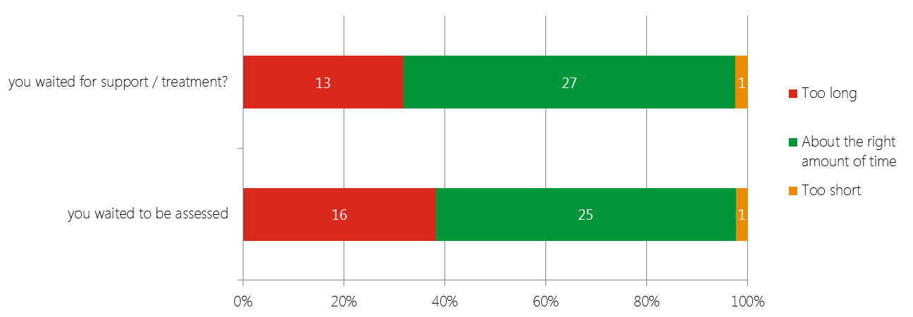
Chart 2
Would you use Let’s Talk again?
(n=41)
Chart 3
How convenient were the appointment session times? (n=41)
Chart 1
How would you rate the Let's Talk service? (n=41)
Chart 4
How did you feel when your support came to an end? (n=30)
Chart 8
How would you rate the type of support you received? n=40)
Chart 6
What support did you receive, and would prefer to receive?
(n=41)
Chart 7
I was given a choice of types of support?
(n=42)
Chart 5
How would you rate the length of time:
(n=41/42)
Service Users
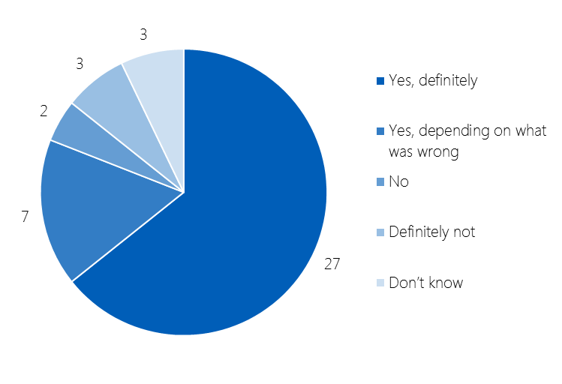
Charts 1 and 2 show that service users value the existing service, with over three quarters rating it good or very good (n=32) and 3 people stating that it was poor or very poor; two thirds saying they would definitely use the service again (n=34), an only 5 people saying they would not use the service again

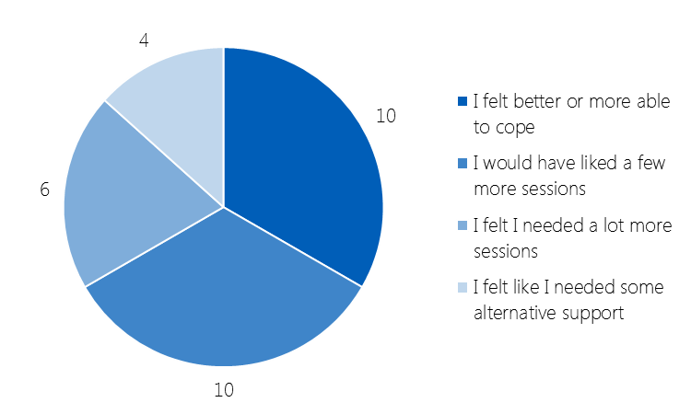
The majority of respondents felt the length of time they waited to be assessed, and to receive support, was about the right amount of time; however about a third felt that they waited too long (chart 3). Only 3 people completing the survey felt that the appointment or session times were inconvenient.

Two thirds (n=26) of respondents were given a choice of the type support they received, however about a quarter (n=11) felt they were not offered a choice of support (chart 7). The majority of participants felt the support they received worked, only a fifth saying that they would have preferred different support or that it did not work for them (chart 8).

Chart 6 shows the type of support people received, and support they would have preferred to receive, although this may give an indication of other forms of support that could be considered, it gives some indication of other services or community groups e.g. social prescribing that might be appropriate to refer to.

Chart 4 shows how people felt when their support came to an end, a third felt better and more able to cope in the future, another third felt that they needed a few more sessions, and the remaining third required notably more support either through a number of further sessions or alternative services.

General Practitioners
All of the GPs taking part in the table top discussion, and taking part in the online survey had heard of the Let’s Talk service; and had referred, or told their patients to self-refer, into the service.

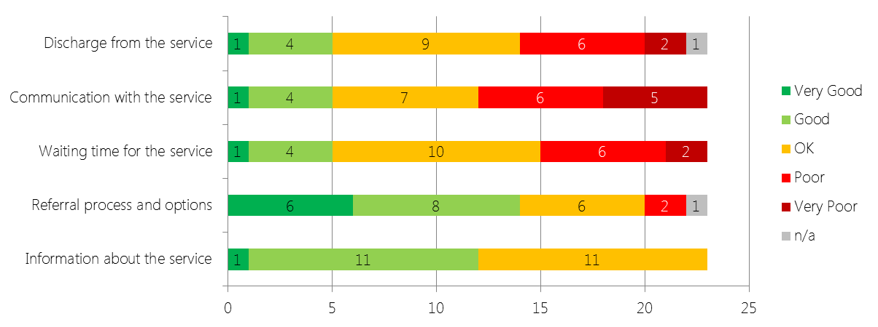
Chart 9 shows that GPs are positive about the information relating to the Let’s Talk service, and the referral process and options. The majority of respondents felt that waiting times were OK or Poor, in almost equal measure, only a quarter felt the waiting time was good or very good (n=5). There is similar feeling for the discharge process. The majority of respondents feel that the communication with the service is poor or very poor (n=11).
Chart 9
How would you rate the following aspects of service? (n=23)

These findings were almost exactly mirrored at the table top discussion session. The discussion session gave more insight into issues with communication and discharge.

There was concern that the service appeared to have a limited number of sessions, rather than tailoring the number of sessions to the individual, reviewing periodically; there was a feeling that this was set at 6 sessions. Some GPs raised concern that after the 6 sessions the patient was sent back to the GP to be referred into service again.

Two different groups were concerned that the Let’s Talk service did not refer people onto secondary care mental health services at the assessment stage, instead returning the patient to the GP to refer; this causing a delay that they felt could be avoided.

All the groups raised discharge letters as a concern; this was mirrored in the free text comments in the questionnaire. GPs felt that the letter, although prompt, did not really give them useful information in what support their patient had received; they felt this inhibited their ability to support the patient following the interventions from Let’s Talk.
Just over a third of GPs rate the service as good or very good, whereas almost half rate it as OK.
Chart 10
How would you rate the Let's Talk service? (n=23)
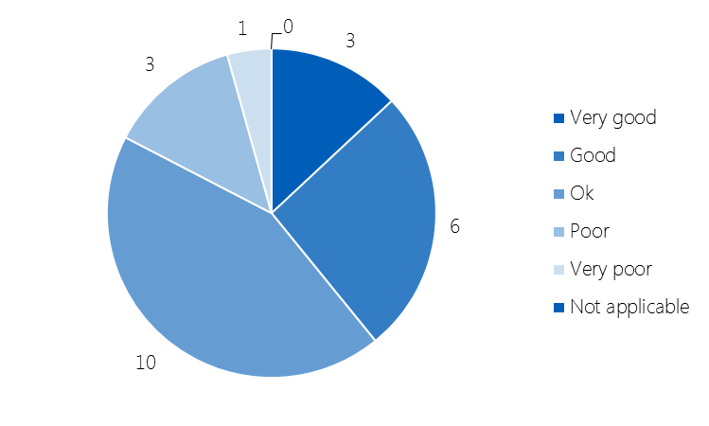
GPs were asked if they could think of any particular reason why the service experiences high DNA rates. Although they thought this could be mainly attributed to the waiting time, some thought that the patient may have recovered from their period of metal ill health.

Members of the public

Chart 11 shows that 70% of members of the public were aware of the Let’s Talk Service, and that just under 40% had access the service. Chart 12 shows people’s experience of mental ill health, the 6 people have most experience of are all catered for within the Let’s Talk service. Chart 13 shows the type of support that people would seek out a number of the popular settings are provided by Let’s Talk.
Chart 11
Public awareness of Let’s Talk service?
(n=418)
Chart 13
Support people are likely to seek
if they had a mild to moderate mental health issue
(n=420)

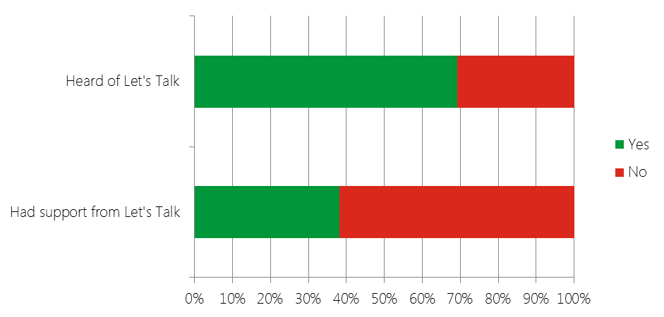
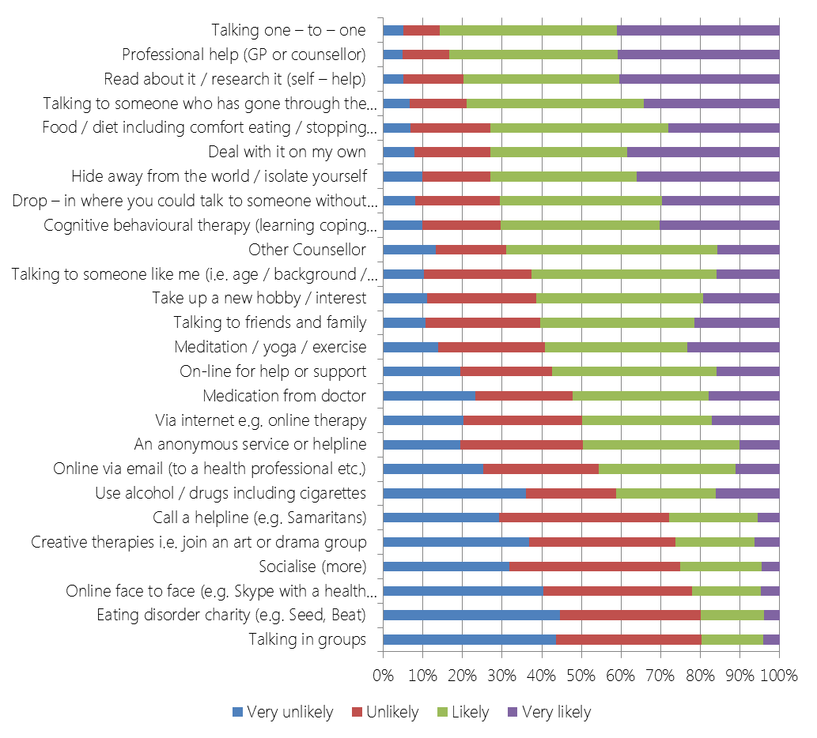

Chart 12
Awareness and experience of mental health issues
(n=491)

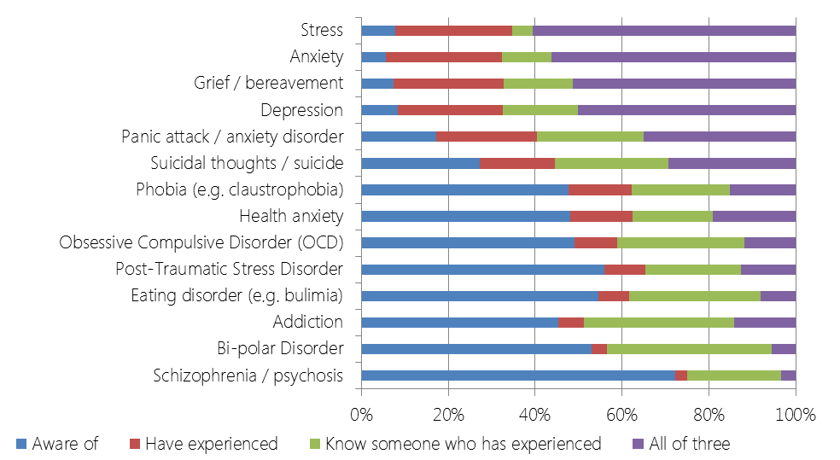

Subcontractors
9 of the # subcontractors that provide the interventions offered by Let’s Talk took part in semi-structured interviews. #SUMMARY TO BE ADDED#

Conclusions

- Awareness of the Let’s Talk service is good, with all GPs who have taken part stating that they are aware of the service, and 70% of the general public stating that they have heard of the service. None of the GPs taking part rated information about the service as poor or very poor.

- The Let’s Talk service is valued by patients, and although this engagement exercise has highlighted some areas where the service could be improved, these issues do not appear severe enough to warrant significant service change.

- The Let’s Talk service currently offers support for mental ill health that people have most experience of. Although patients suggested alternative methods of support may be preferred, none surpassed the methods currently offered. A number of the preferred support settings identified by the general public are currently provided by the Let’s Talk service. This suggests that what the service offers is meeting the needs of patients, but some alternatives or links with organisations or services should be considered.

- The key service issues seem to be:
  - Waiting times for assessment and support: Although the majority of patients feel the wait is about right, about a third feel the waiting time is too long; GPs feel that the waiting time to access the service is too long and that this contributes to the high DNA rate the service experiences.
  - The number of sessions offered: The way this is determined needs to be reviewed, as there is a perception that a limited number are offered; this was highlighted by GPs and about half of patients taking part in this exercise felt they needed more sessions when their intervention came to an end.
  - Clinical Communication: Based on the feedback from GPs, this needs to be improved particularly at discharge. The GPs main concern relates to the information they receive but also relates to how the Let’s Talk service refers on to other services.

- This report is a summary analysis, and it is recommended that further analysis and engagement be undertaken to inform any service improvements.

