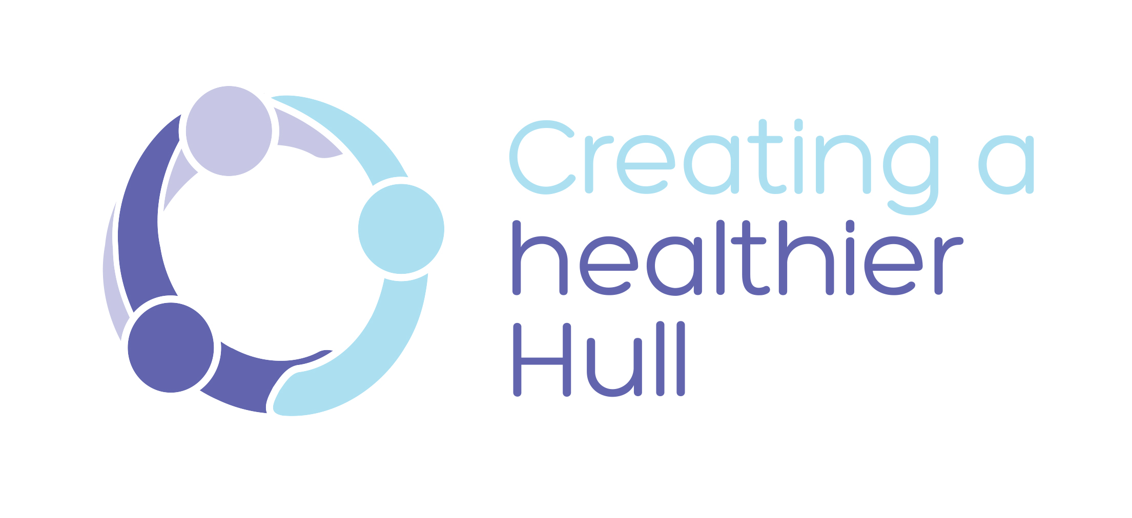

NAME OF POLICY

MONTH / YEAR

Important: This document can only be considered valid when viewed on the CCG’s website.

If this document has been printed or saved to another location, you must check that the version number on your copy matches that of the document online.

If you need this document in a different format or language (e.g. large print, Braille, audio or easy read), please contact us on 01482 344700, or email HULLCCG.contactus@nhs.net, or write to: NHS Hull Clinical Commissioning Group, 2nd Floor, Wilberforce Court, Alfred Gelder Street, Hull HU1 1UY.

Name of Policy:

Date Issued:

Date to be reviewed:

Policy Title:

Supersedes: (Please List)

Description of Amendment(s):

This policy will impact on:

Policy Area:

Version No:

Author:

Effective Date:

Review Date:

Equality Impact Assessment Date:
APPROVAL RECORD |  |  | Date:
Consultation:

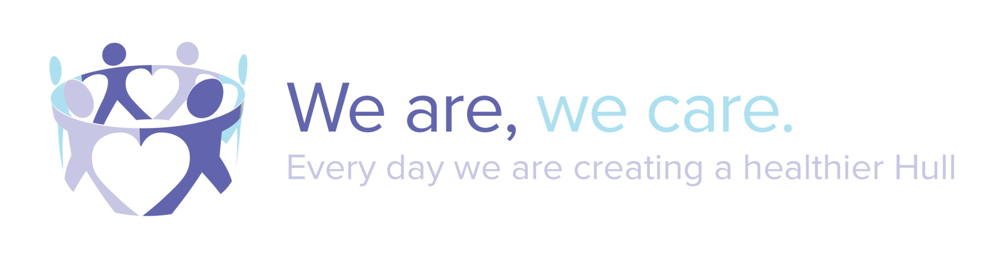
CONTENTS

 |  | Page
1. | INTRODUCTION
2. | SCOPE
3. | POLICY PURPOSE AND AIMS
4.  4.1  4.2 | IMPACT ANALYSIS  Equality  Bribery Act 2010
5.  5.1  5.2 | NHS CONSTITUTION  The CCG is committed to:  This Policy supports the NHS Constitution and
6 | ROLES / RESPONSIBILITIES / DUTIES
7. | IMPLEMENTATION
8. | TRAINING AND AWARENESS
9. | MONITORING AND EFFECTIVENESS
10. | POLICY REVIEW
11. | REFERENCES
12. | ASSOCIATED DOCUMENTATION
APPENDICES
Appendix 1
Appendix 2

1. INTRODUCTION

2. SCOPE

3. POLICY PURPOSE AND AIMS

4. IMPACT ANALYSIS

4.1 Equality

The CCG is committed to:

4.2 Bribery Act 2010

NHS Hull Clinical Commissioning Group has a responsibility to ensure that all staff are made aware of their duties and responsibilities arising from The Bribery Act 2010.

The Bribery Act 2010 makes it a criminal offence to bribe or be bribed by another person by offering or requesting a financial or other advantage as a reward or incentive to perform a relevant function or activity improperly performed. The penalties for any breaches of the Act are potentially severe. There is no upper limit on the level of fines that can be imposed and an individual convicted of an offence can face a prison sentence of up to 10 years.

For further information see http://www.justice.gov.uk/guidance/docs/bribery-act-2010-quick-start-guide.pdf.

If you require assistance in determining the implications of the Bribery Act please contact the Local Counter Fraud Specialist on telephone number 01482 866800 or email at nikki.cooper1@nhs.net.

Due consideration has been given to the Bribery Act 2010 in the development of this policy (or review, as appropriate) of this policy document and no specific risks were identified. (If this is not particularly relevant to this policy)

5. NHS CONSTITUTION

5.1 The CCG is committed to:

5.2 This Policy supports the NHS Constitution and

6. ROLES / RESPONSIBILITIES / DUTIES

6.1 Lead

6.2 Employees

6.3 Line Manager

7. IMPLEMENTATION

8. TRAINING AND AWARENESS

9. MONITORING AND EFFECTIVESNESS

The effectiveness of this Policy will be monitored by

10. POLICY REVIEW

This Policy will be reviewed within from the date of implementation.

11. REFERENCES

12. ASSOCIATED DOCUMENTATION

APPENDICES

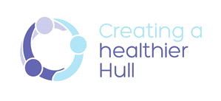

Please refer to the EIA Overview & Navigation Guidelines located in Y:\HULLCCG\Corporate Templates and Forms\Equality and Diversity Information before completing your EIA)

HR / Corporate Policy Equality Impact Analysis:

Policy / Project / Function:
Date of Analysis:
Completed by:
(Name and Department)
What are the aims and intended effects of this policy, project or function?
Are there any significant changes to previous policy likely to have an impact on staff / other stakeholder groups?
Please list any other policies
that are related to or referred to as part of this analysis

Who will the policy, project or function affect?
What engagement / consultation has been done, or is planned for this policy and the equality impact assessment?

Promoting Inclusivity and Hull CCG’s Equality Objectives.

How does the project, service or function contribute towards our aims of eliminating discrimination and promoting equality and diversity within our organisation?

How does the policy promote our equality objectives:
- Ensure patients and public have improved access to information and minimise communications barriers
- To ensure and provide evidence that equality is consciously considered in all commissioning activities and ownership of this is part of everyone’s day-to-day job
- Recruit and maintain a well-supported, skilled workforce, which is representative of the population we serve
- Ensure the that NHS Hull Clinical Commissioning Group is welcoming and inclusive to people from all backgrounds and with a range of access needs

Equality Data

Is any Equality Data available  relating to the use or  implementation of this policy,  project or function?  Equality data is internal or external information that may indicate how the activity being analysed can affect different groups of people who share the nine Protected Characteristics – referred to hereafter as ‘Equality Groups’.  Examples of Equality Data include: (this list is not definitive)  1: Recruitment data, e.g. applications compared to the population profile, application success rates  2: Complaints by groups who share / represent protected characteristics  4: Grievances or decisions upheld and dismissed by protected characteristic group  5: Insight gained through engagement | Yes  No  Where you have answered yes, please incorporate this data when performing the Equality Impact Assessment Test (the next section of this document). If you answered No, what information will you use to assess impact?  Please note that due to the small number of staff employed by the CCG, data with returns small enough to identity individuals cannot be published. However, the data should still be analysed as part of the EIA process, and where it is possible to identify trends or issues, these should be recorded in the EIA.

Assessing Impact
Is this policy (or the implementation of this policy) likely to have a particular impact on any of the protected characteristic groups?
(Based on analysis of the data / insights gathered through engagement, or your knowledge of the substance of this policy)
Protected  Characteristic: | No  Impact: | Positive  Impact: | Negative  Impact: | Evidence of impact and, if applicable, justification where a Genuine Determining Reason exists (see footnote below – seek further advice in this case)
It is anticipated that these guidelines will have a positive impact as they support policy writers to complete meaningful EIAs, by providing this template and a range of potential issues to consider across the protected characteristics below. There may of course be other issues relevant to your policy, not listed below, and some of the issues listed below may not be relevant to your policy.
Gender
Age
Race / ethnicity / nationality

Disability

Religion or Belief
Sexual Orientation

Pregnancy and Maternity
Transgender / Gender reassignment
Marriage or civil partnership

Action Planning:
As a result of performing this analysis, what actions are proposed to remove or reduce any risks of adverse impact or strengthen the promotion of equality?

Identified Risk: | Recommended Actions: | Responsible Lead: | Completion Date: | Review Date:

Sign-off
All policy EIAs must be signed off by Mike Napier, Associate Director of Corporate Affairs
I agree / disagree with this assessment / action plan

If disagree, state action/s required, reasons and details of who is to carry them out with timescales:

Signed:
Date:

- The action is proportionate to the legitimate aims of the organisation (please seek further advice)

