National Walking Month – May 2019
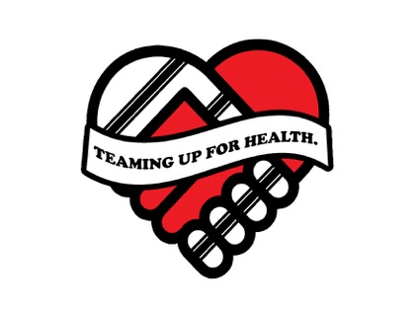
Walking Challenge
The Teaming up for health partnership are inviting fans of the Rugby League Clubs, Hull 2020 Health Champions and the Hull Working Voices employees to complete and log walking during May which is National Walking Month.
Each time you walk for at least 20 minutes, where you can talk but not sing, please give yourself a tick on the calendar below. At the end of the month please return by Wednesday 6th June 2019. Alternatively, please log your walks within the following link: https://www.surveymonkey.co.uk/r/TufHNWM2019. After this date the winning team will be announced.
Hull KR | Hull FC
Lizzie.Borrill@hullkr.co.uk | Olivia.Jackson@hullfc.com
Community Trust  KCOM Craven Park  Poorhouse Lane  Hull HU9 5HE | Community Foundation  The KC Stadium  West Park  Hull HU3 6HU
2020 Health Champions | Working Voices
Emma.Kelly25@nhs.net  Christine.ebeltoft@nhs.net | samantha.barlow@nhs.net
NHS Hull CCG  2nd Floor, Wilberforce Court  Alfred Gelder Street  Hull HU1 1UY | NHS Hull CCG  2nd Floor, Wilberforce Court  Alfred Gelder Street  Hull HU1 1UY

Please utilise the following in social media #hullthy, teaming up for health, @hullkrofficial, @HullChampions, @hullfcofficial, @NHSHullCCG, @HealthHull and @hullccnews.
Name:

Organisation:

Wed 1st |  | Fri 17th
Thur 2nd |  | Sat 18th
Fri 3rd |  | Sun 19th
Sat 4th |  | Mon 20th
Sun 5th |  | Tues 21th
Mon 6th |  | Wed 22nd
Tues 7th |  | Thur 23rd
Wed 8th |  | Fir 24th
Thur 9th |  | Sat 25th
Fir 10th |  | Sun 26th
Sat 11th |  | Mon 27th
Sun 12th |  | Tue 28th
Mon 13th |  | Wed 29th
Tue 14th |  | Thur 30th
Wed 15th |  | Fri 31st
Thur 16th

