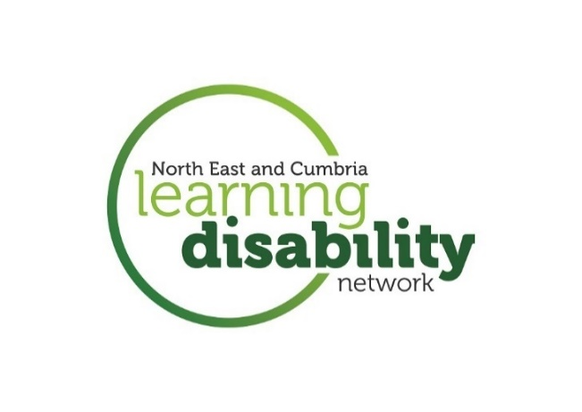

**Keeping people with a learning disability/autism connected across North Cumbria and North East**

**Looking after yourself: links to websites**

**Public Health England - New advice to support mental health during coronavirus outbreak**

<https://www.gov.uk/government/news/new-advice-to-support-mental-health-during-coronavirus-outbreak>

**Every mind matters –** looking after your mental health

<https://www.nhs.uk/oneyou/every-mind-matters/>

<https://www.nhs.uk/oneyou/every-mind-matters/coronavirus-covid-19-staying-at-home-tips/>

**Managing our anxiety about loss – Kings Fund**

<https://www.kingsfund.org.uk/publications/managing-anxiety-about-loss-covid-19?utm_source=The%20King%27s%20Fund%20newsletters%20%28main%20account%29&utm_medium=email&utm_campaign=11492147_NEWSL_The%20Weekly%20Update%202020-04-24&utm_content=managing_anxiety_button&dm_i=21A8,6UBEB,WRYN9O,RFE4Z,1>

**Stay in, work out -** Tips, advice and guidance on how to keep or get active in and around your home.

<https://www.sportengland.org/stayinworkout#get_active_at_home>

**Coronavirus Anxiety Workbook** - A tool to help

build resilience during difficult times

<https://thewellnesssociety.org/free-coronavirus-anxiety-workbook/>

**Helping Each Other -** How can we combat fears of not coping, not being good enough or letting others down?<https://covid.minded.org.uk/helping-each-other/>