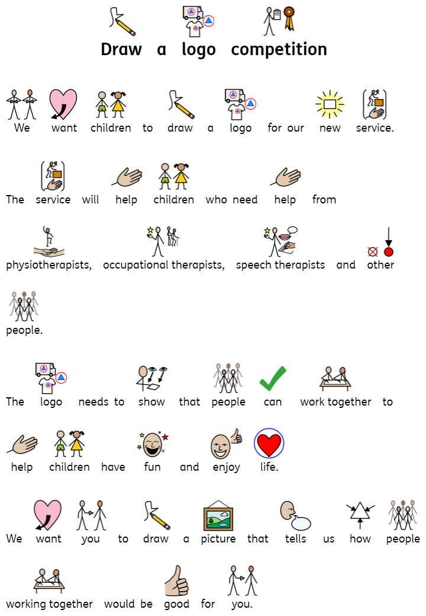

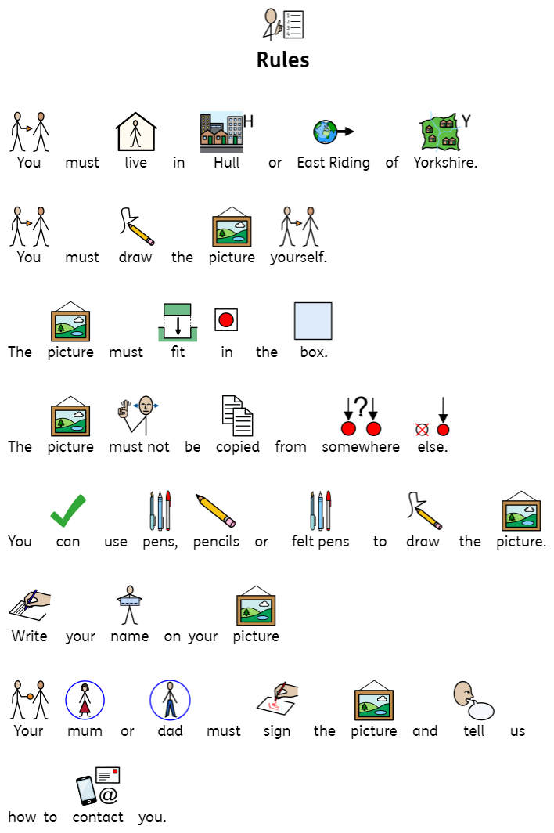
RTGL-RGEB-JABG
Engagement Team
NHS HULL Clinical Commissioning Group
2nd Floor
Wilberforce Court
Alfred Gelder Street
Hull
HU1 1UY

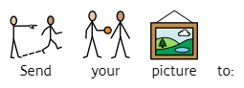

Hull & East Riding Children’s Neurodiversity Service
Draw a Logo Competition
Competition Entry Form
Name:
Age:
School:
Parent’s Signature:
Parent’s Contact Telephone Number or email address:
Date of Entry:
Remember to keep your drawing inside the box below:

