HUMBER CHILDREN’S COMMUNITY PROGRAMME
Children’s Palliative and End of Life Care Project: Children, young people, and family experiences
The Humber Children’s Partnership is working collectively with the four Clinical Commissioning Groups (CCGs) and Local Authorities (Hull, East Riding of Yorkshire, North East Lincolnshire and North Lincolnshire), and the providers of health and care services with a focus on improving children’s services across the Humber region. This work aims to improve the experiences and outcomes for children and young people and their families.

One of the projects is focusing on services that provide care and support to children and young people with Palliative and End of Life Care (PEoLC) needs and their families and ensuring that across the Humber we achieve the requirements of the NHS Long Term Plan, the national PEoLC Strategy (expected October 2021) and the regional Yorkshire and Humber Children’s Palliative Care Network (YHPCN) Strategy.

A series of 7 workshops are being held over the next 6 months that will focus on the needs of children, young people and their families based on their care journey from the point of diagnosis to bereavement support. As part of these sessions, we would very much like to hear your lived experience and views. This is essential to help us understand what is working well and is well provided for, as well as those experiences where things haven’t gone so well, or there have been gaps or difficulties in accessing or delivering the care and support that is needed.

What we are looking for

We are looking for children, young people, and families to share their lived experiences and views of their care journey to help shape the discussions for each workshop.
Examples of experiences and views you may wish to share:
- Care and support around the time of diagnosis
- Access to and delivery of care and support
- Access to and delivery of end of life care and support
- Access to and delivery of bereavement support
- Your experience of transition from children and young people services to adult heath care services
We are keen to hear about all experiences, positive and negative. We welcome messages on resilience, adapting to changing circumstances and coping with adversities.

How you can help us
There are a several ways you can share your stories with us. You can share your views independently by:

Recording a short video clip on a mobile phone or another device that tells your story and experience. (See ‘Tips when recording a video’ (page 3) for guidance on how to do this).

Please send your video
- via WeTransfer (guidance here) to HULLCCG.contactus@nhs.net,
OR
- via WhatsApp to Bernie Dawson (NHS Hull CCG) on 07808 395611

Email a written reflective account or narrative of your experiences and views (See ‘Tell us your story’ (page 3) for guidance) to HULLCCG.contactus@nhs.net

We welcome more creative representations of experiences too such as artwork or poems, which may help children and young people to share their thoughts and feelings.
Send creative representations:
- by emailing a scanned image to HULLCCG.contactus@nhs.net
OR,
- by taking a photograph and sending via WhatsApp to Bernie Dawson (NHS Hull CCG) on 07808 395611

If you would like some support in being able to share your experiences and views, please email HULLCCG.contactus@nhs.net and a member of the team will be in touch to agree how we can support you.

What happens next?
Your experiences will be pulled together alongside other family and staff experiences and views. These will be shared in the workshops to bring to life presentations from key speakers and inform the smaller group discussions we have planned.
There may be opportunities for your stories to inform wider pieces of work, training, and development around Children’s Palliative and End of Life Care.

Please complete the consent forms attached to give permission for you and your family’s stories to be used in the upcoming workshops and any future pieces of work.
We would like to take this opportunity thank you so much for taking the time to work with us. If you have any queries, please get in touch with the team via HULLCCG.contactus@nhs.net

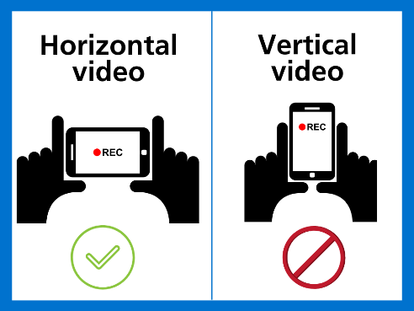
Tips when recording your video

- Ensure your background is appropriate.

- Hold your phone horizontally with the person in the centre of the screen. Try to film as a headshot so we can only see from the person’s shoulder upwards.

- Ensure the sound is clear and try to avoid filming in busy or noisy spaces.

- Try to film in natural light wherever possible. If you can’t film during the day, try to position yourself where lights don’t cast a shadow over your face.

- Tap the screen on your phone to focus the video on your face.

We can edit the video a little so don’t worry about it being perfect.

Tell us your story

- Please tell us whether you are a child, young person, parent, carer or family member
- Please explain a little about your current situation.
- When did you first discover that your child had a health problem?
- What process did you go through to obtain a diagnosis? What was your experience of that?
- What kind of care have you received since then to support you? If you are getting support from different sources, please tell us a little bit about those, and what you have/have not found useful
- If your child’s condition has progressed or deteriorated over time, how do you feel their condition has been managed?
- Are there any types of additional support or services that you would find beneficial? This could be for you, your child, or the family as a whole.
- If your child has moved into adult services, how did you and your child find that transition? What support did you receive?
- Have you experiences end of life care for your child? If so, what support did you receive? bereavement support was available to you if you wanted it?
- What do you think is working/ has worked well and is well provided for you and/or your family’s needs? Why does/ did this work well?
- What are / have been the challenges in receiving the quality of care and support that you and/or your family have expected and/or needed?
- What needs to happen to improve services for you and/or your family and/or other children and young people with PEoLC needs and their families?
- Is there one particular moment or memory regarding the care you and/or your family has received that you think the healthcare community can learn from? This can be either an example of great practise, or something which you would have liked to have gone differently.
- Are there any other comments you wish to make about the care and support that you have received?

